Directions: Please fill in Part Ι as you study the Reading Assignment. Be sure it is completed before you attend Group Preparation. You will complete Part II of this document with your group.
Part I:

- What is the null hypothesis for the significance test comparing two population proportions?
$$H_{o}: p_{1}= p_{2}$$

- What is the formula for a test statistic for testing two population proportions? Explain what each variable stands for in your formula.
$$z= \frac{\left({\hat{p}}_{1}-\hat{p_{2}}\right)-(p_{1}-p_{2})}{\sqrt{\hat{p}\left(1-\hat{p}\right)\left(\frac{1}{n_{1}}+\frac{1}{n_{2}}\right)}}$$

$${\hat{p}}_{1}=Sample proportion for group 1$$
$${\hat{p}}_{2}=Sample proportion for group 2$$
$$\hat{p}=Overall sample proportion$$
$$n_{1}=Sample size for group 1$$
$$n_{2}=Sample size for group 2.$$

- What is the confidence interval for comparing two proportions? Explain what each variable stands for in your formula.
$$\left({\hat{p}}_{1}-{\hat{p}}_{2}\right)±z*\sqrt{\frac{{\hat{p}}_{1}\left(1-{\hat{p}}_{1}\right)}{n_{1}+2}+\frac{{\hat{p}}_{2}(1-{\hat{p}}_{2})}{n_{2}+2}}$$
$${\hat{p}}_{1}=Sample proportion for group 1$$
$${\hat{p}}_{2}=Sample proportion for group 2$$
$$n_{1}=Sample size for group 1$$
$$n_{2}=Sample size for group 2$$
$$z* =z value for a confidence interval$$

Part II: You will complete Part II with your group at Group Preparation

- There was a recent survey taken on whether consumers are “label users” who pay attention to label details when buying clothes. Are men and women equally likely to be label users? Determine if the proportion of men who use labels are different than the proportion women who use labels with a level of significance of α = 0.05.
Here is the data summary:
Population | Sample Size | X
Women | 296 | 63
Men | 251 | 27
X= Number of people who use labels for shopping
  - Check the Requirements.
$$296 x 0.213=63>10$$
$$251 x 0.108=27>10$$
$$296\left(1-0.213\right)=233>10$$
$$251\left(1-0.108\right)=224>10$$

  - State the null and alternative hypotheses
$$H_{o}: p_{1}=p_{2}$$
$$H_{a}: p_{1}≠p_{2}$$
  - Compute the Test Statistic
$$z=3.309$$

  - Compute the P-value
P-value = 0.001

  - Shade your P-value on the normal distribution curve with the Test statistic labeled.
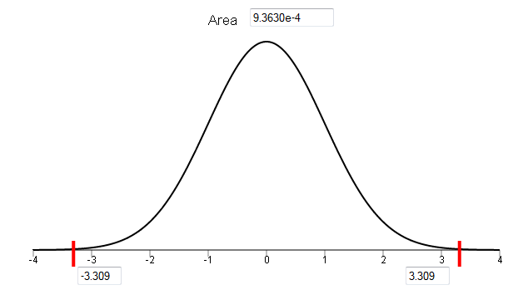
Students should include a sketch of normal distribution curve with both to the left and right of the two z-scores shaded.

  - What decision do you make about the null hypothesis?
Reject the null
  - State your conclusions in “layman’s terms”.
We have sufficient evidence to say that there is a difference in the proportions of men who use labels and women who use labels.

- Construct a 95% confidence interval for the difference of the two proportions in #4.
(0.045, 0.166)

- Interpret the confidence interval you constructed in #5.
We are 95% confident that the true difference in the proportions of men being label users and women being label users is between 0.045 and 0.166.

